**University of Ghana - Department of Computer Science**

Welcome to the official repository of the University of Ghana's Department of Computer Science website!

**Table of Contents**

* [Overview](https://chat.openai.com/c/9049734e-c015-4465-8a92-ccb0877b5f76#overview)
* [About Us](https://chat.openai.com/c/9049734e-c015-4465-8a92-ccb0877b5f76#about-us)
* [Faculty](https://chat.openai.com/c/9049734e-c015-4465-8a92-ccb0877b5f76#faculty)
* [Events](https://chat.openai.com/c/9049734e-c015-4465-8a92-ccb0877b5f76#events)
* [Alumni Network](https://chat.openai.com/c/9049734e-c015-4465-8a92-ccb0877b5f76#alumni-network)
* [Contact Us](https://chat.openai.com/c/9049734e-c015-4465-8a92-ccb0877b5f76#contact-us)
* [Student Projects and Catalog](https://chat.openai.com/c/9049734e-c015-4465-8a92-ccb0877b5f76#student-projects-and-catalog)

**Overview**

The Overview page serves as the homepage for the Department of Computer Science website. It provides a brief introduction to the department and its mission.

**About Us**

The About Us page provides detailed information about the department, including its history, vision, and mission. Learn more about the faculty, research initiatives, and the department's commitment to excellence in computer science education.

**Faculty**

The Faculty page showcases the talented educators and researchers within the department. Get to know the academic and research profiles of our esteemed faculty members.

**Events**

Stay informed about upcoming events related to the Department of Computer Science. The Events page provides details about seminars, conferences, and other important dates.

**Alumni Network**

Connect with our alumni through the Alumni Network page. Learn about their success stories, career paths, and how you can become part of the growing community.

**Contact Us**

Have questions or need assistance? The Contact Us page provides contact information for the department. Reach out via phone or email, and visit our physical location on the University of Ghana's Legon Campus.

**Student Projects and Catalog**

Explore the exciting projects undertaken by our students. The Student Projects and Catalog page provides insights into the innovative work produced by our talented student body.

**Cloning or Setup**

**University of Ghana - Department of Computer Science**

Welcome to the official repository of the University of Ghana's Department of Computer Science website!

**Table of Contents**

* [Overview](https://chat.openai.com/c/9049734e-c015-4465-8a92-ccb0877b5f76#overview)
* [About Us](https://chat.openai.com/c/9049734e-c015-4465-8a92-ccb0877b5f76#about-us)
* [Faculty](https://chat.openai.com/c/9049734e-c015-4465-8a92-ccb0877b5f76#faculty)
* [Events](https://chat.openai.com/c/9049734e-c015-4465-8a92-ccb0877b5f76#events)
* [Alumni Network](https://chat.openai.com/c/9049734e-c015-4465-8a92-ccb0877b5f76#alumni-network)
* [Contact Us](https://chat.openai.com/c/9049734e-c015-4465-8a92-ccb0877b5f76#contact-us)
* [Student Projects and Catalog](https://chat.openai.com/c/9049734e-c015-4465-8a92-ccb0877b5f76#student-projects-and-catalog)

**Overview**

The Overview page serves as the homepage for the Department of Computer Science website. It provides a brief introduction to the department and its mission.

**About Us**

The About Us page provides detailed information about the department, including its history, vision, and mission. Learn more about the faculty, research initiatives, and the department's commitment to excellence in computer science education.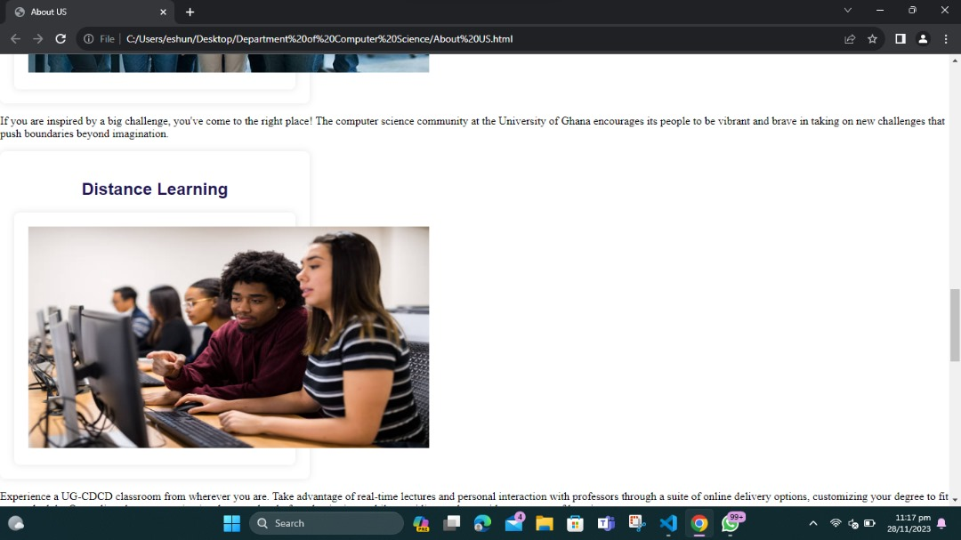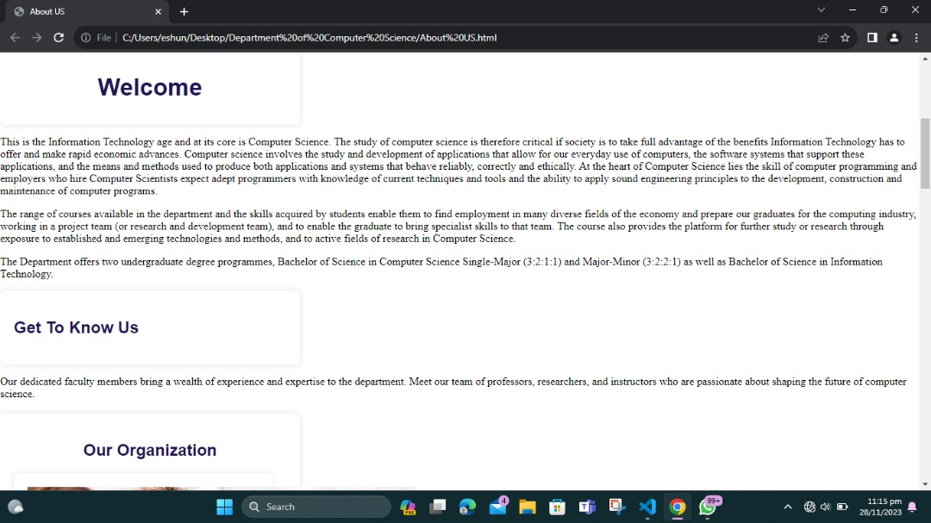

**Faculty**

The Faculty page showcases the talented educators and researchers within the department. Get to know the academic and research profiles of our esteemed faculty members.

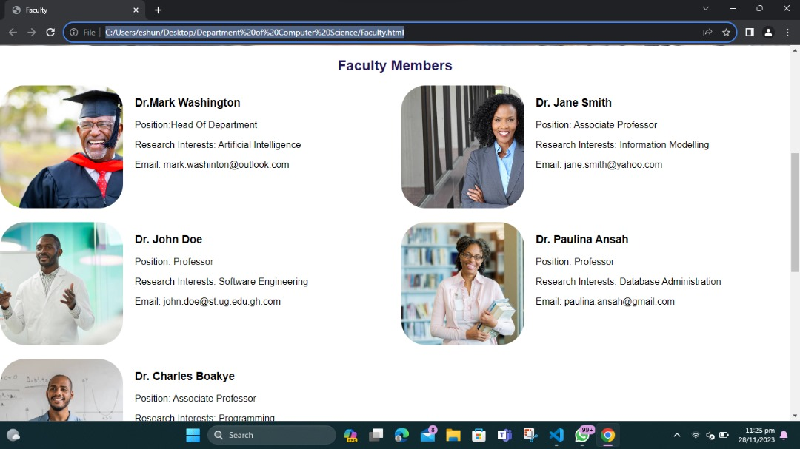

**Events**

Stay informed about upcoming events related to the Department of Computer Science. The Events page provides details about seminars, conferences, and other important dates.

**Alumni Network**

Connect with our alumni through the Alumni Network page. Learn about their success stories, career paths, and how you can become part of the growing community.

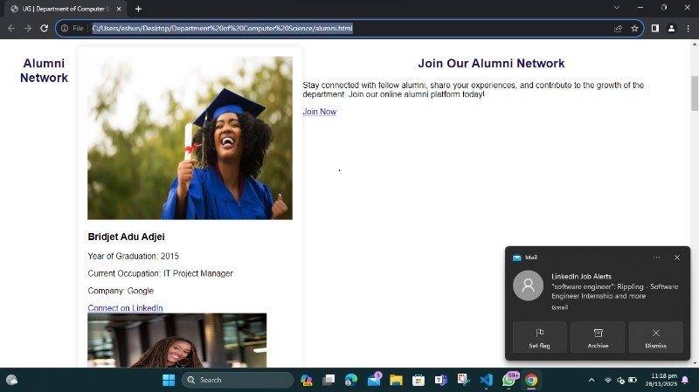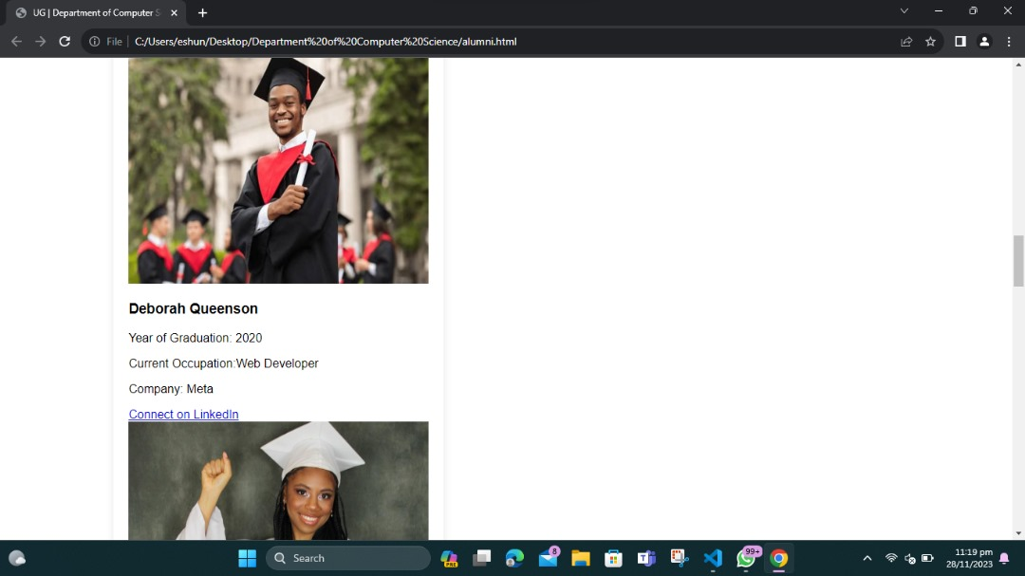

**Contact Us**

Have questions or need assistance? The Contact Us page provides contact information for the department. Reach out via phone or email, and visit our physical location on the University of Ghana's Legon Campus.A screenshot of a computer

**Student Projects and Catalog**

Explore the exciting projects undertaken by our students. The Student Projects and Catalog page provides insights into the innovative work produced by our talented student body.

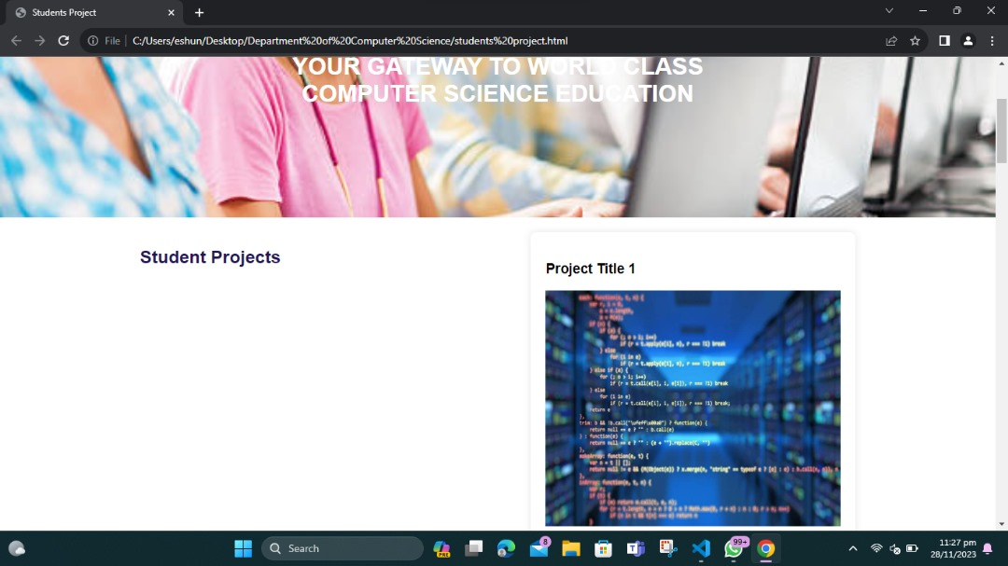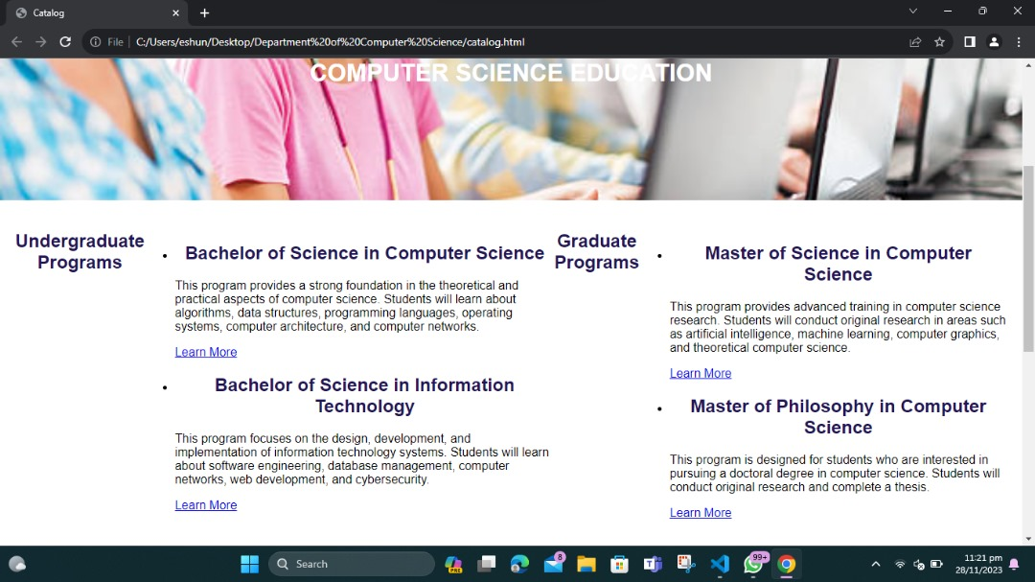

**Cloning or Setup**

1.Clone the repository:

**git clone <your-repo-url>**

**2.** Navigate to the project directory:

**cd <project-directory>**

**3.** **Open the project in your preferred code editor.**

**4.Open the HTML files in your browser or set up a local development server.**

**If you have Python installed, you can use the following command in the project directory:**

**python -m http.server**

**This will start a local server, and you can view the website by navigating to http://localhost:8000 in your browser.**

**5.Explore the different pages and enjoy browsing the Department of Computer Science website!**

**Feel free to contribute or provide feedback. We appreciate your interest in our department!**